How do I avoid feeling overwhelmed during classes and lectures?
Formal education
The root of in-class overwhelm
Although the techniques we teach you will help you to improve your overall learning ability massively, it doesn't happen overnight.
If you are struggling to process fast enough in class or lectures, there are a few key considerations and tips.
Prestudy
Your brain struggles to try and understand what to know if it doesn't know why it's relevant.
Prestudy primes your brain to know how to think about new information and how to assign it relevance. The most common reason for struggling to process during class is a lack of relevance. The brain is trying to learn the information and place it somewhere, but because there is no organisational structure, it doesn't know where to place it.
This creates cognitive overload, and unless your processing ability is at a higher-intermediate to advanced level, this will be impossible to manage.
Prestudying separates these processes by helping you to build a big-picture scaffold of the information first, so that during class you can simply focus on connecting the information and integrating it into your existing network.
Key principle
Never sacrifice prestudy. If you only have time to review something you've already learned or prestudy something you're about to learn, always choose prestudy. Effective prestudy reduces how much you will forget moving forward. Sacrificing this step puts you in a detrimental position, fighting uphill against a forgetful memory. If the future version of you forgets less (due to prestudy), you can always find time elsewhere to review what you've already learned.
As the images below illustrate, prestudy gives new information a place to fit. Potential connections have already been scoped and hypothesised. The brain is able to use its limited resources to understand the new information, connect it to our network of knowledge, and evaluate whether it makes sense.
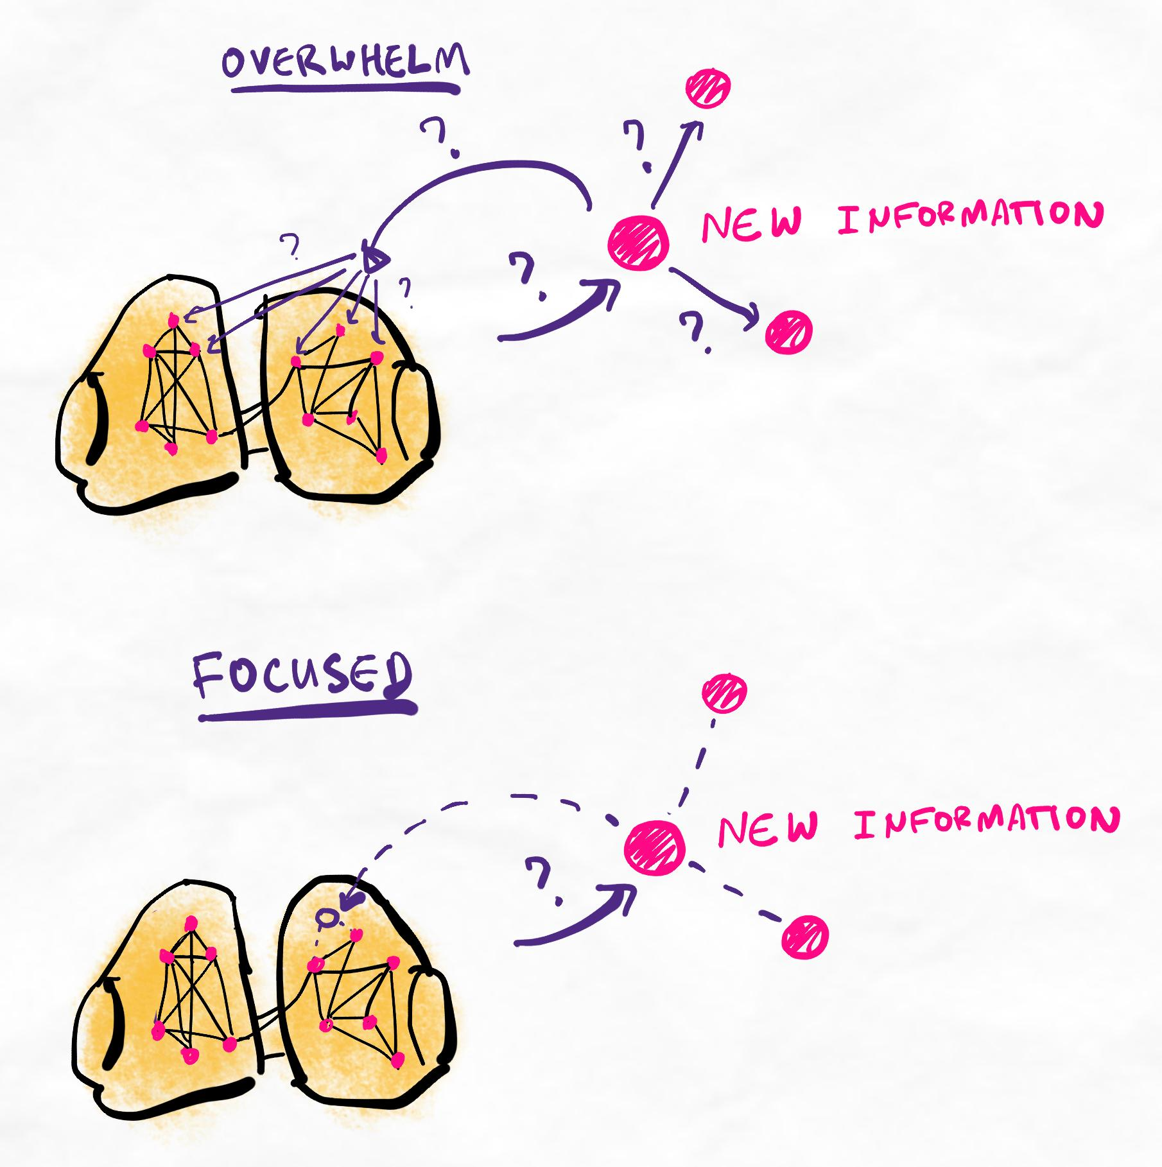
In most instances, effective prestudy means you should be able to think faster than a person can teach. This translates to asking deeper, more meaningful questions and being able to extract more value from your lesson and teaching session.
Consider your marginal gains
Another reason for being overwhelmed may be that you are currently unable to process auditory information efficiently because the necessary cognitive skills are underdeveloped. There is no way around this other than diligent training over time.
The techniques we teach will allow you to train and improve this as long as you approach your practice as instructed, following our practice guidelines.
Training your ability to process auditory information
- Listen and try to connect the new information to your prior knowledge as much as possible. Simplify the information, group/chunk it, and find similarities/differences while they are speaking.
- When you feel like you are unable to hold onto any more information mentally, quickly map out all of your current thoughts on your notes.
- Repeat from step 1, but now referencing your mapped notes occasionally to look for more ways to connect, simplify and group information.
- Continue this process and aim to process 1% more information mentally by per attempt, before needing to write it down. At the university level, 10 to 15 minutes during a dense lecture before needing to offload signifies a high level of processing ability.

